**Practical 2**

**Objectives:** Understand the skills and knowledge required for an Ethical Hacker

**Exercise Explore Security Certifications**

1. Go to www.eccouncil.org. Look for information on the Certified Ethical Hacker training.
2. Still in www.eccouncil.org, go to “About EC-Council”. Click on Code of Ethics. Look through the Code of Ethics expected of Ethical Hackers.
3. Go to [www.isc2.org/Certifications/CISSP](http://www.isc2.org/Certifications/CISSP). Click on “2. Register and Prepare for the Exam” to see the 8 CISSP Domains covered in the CISSP certification.

**Exercise Explore SANS website**

1. Go to www.sans.org. Under Resources, click on The Critical Security Controls. Click on the CIS Critical Security Controls (<http://www.cisecurity.org/critical-controls>).

These are a recommended set of actions that companies can follow to protect their networks.

1. Browse through the CIS Controls.

The following are some screenshots extracted from the CIS Controls, for reference.

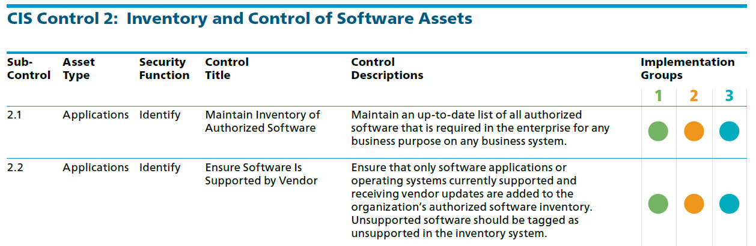

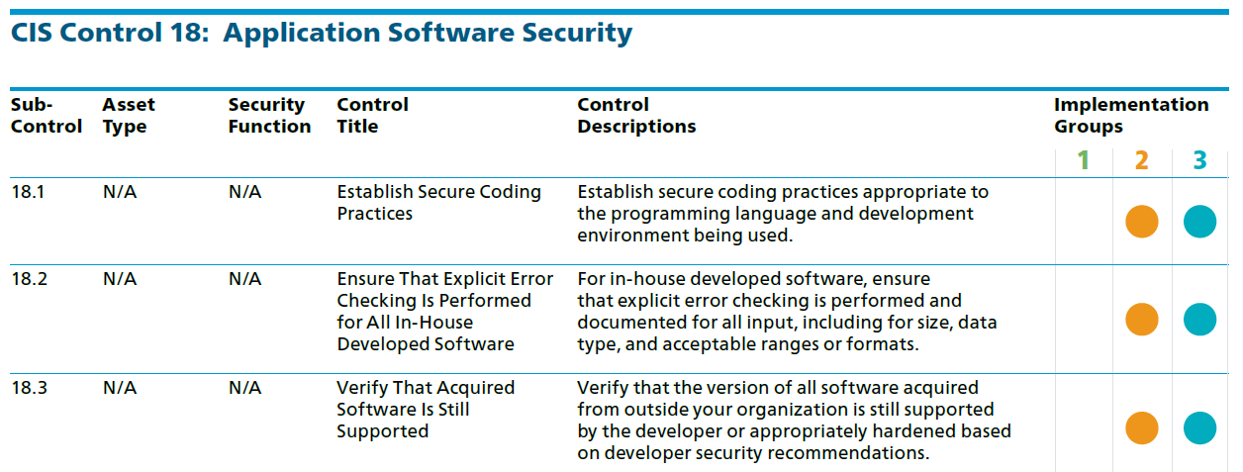

**Exercise Career Opportunities**

1. Search for job postings of penetration testers. What are the skills needed? Are professional certifications required?

**Exercise Write a simple test report**

1. Scan your web-server2 system and produce a simple test report like the one below. Add in more rows for the Ports and Vulnerabilities if required. (a sample test report is available on Blackboard, just for reference)

|  |  |
| --- | --- |
| IP address | OS |
| 192.168.126.88 | Apache/2.4.6 (CentOS) OpenSSL/1.0.1e-fips |

|  |  |  |  |
| --- | --- | --- | --- |
| Port | TCP or UDP | Protocol name | Remarks (eg banner information) |
| 21 | TCP | ftp ( file transfer protocol) |  |
| 22 | TCP | ssh (secure shell) |  |
| 23 | TCP | telnet |  |

|  |
| --- |
| Concern or Vulnerability #1 |
| telnet transfers data in plain text |
| Recommendations |
| Disable telnet service |

**Exercise Test your Understanding**

1. Do the Ethical Hacker Quiz on Brightspace for General Performance marks.

*End of Practical*